**Ans:select salesman_id,salesman_name,order_date,order_no,purchase _amount from orders**;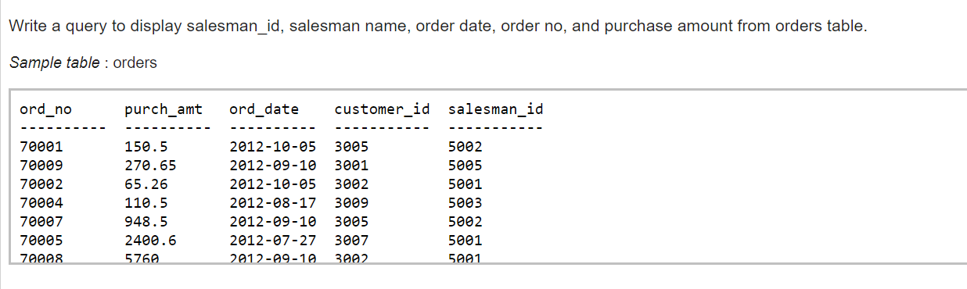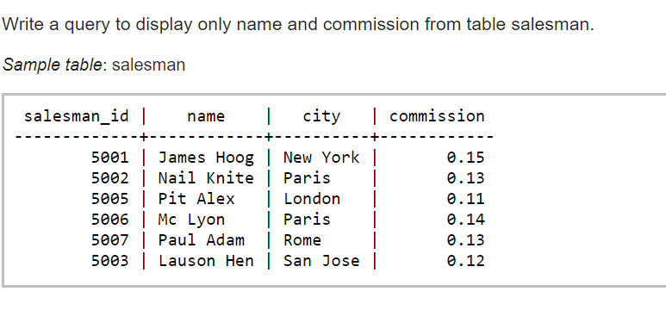

**Ans: select name,commission from salesman;**

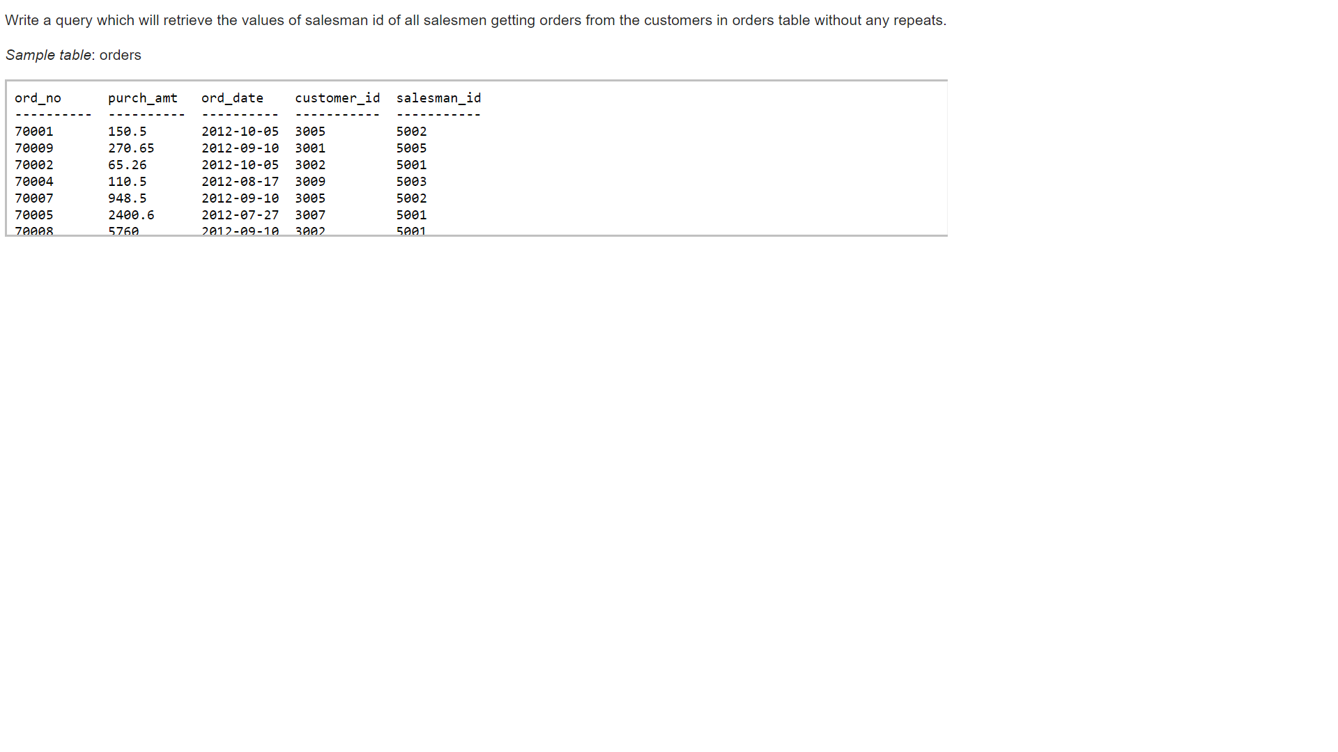

**Ans : select distinct salesman_id from orders;**

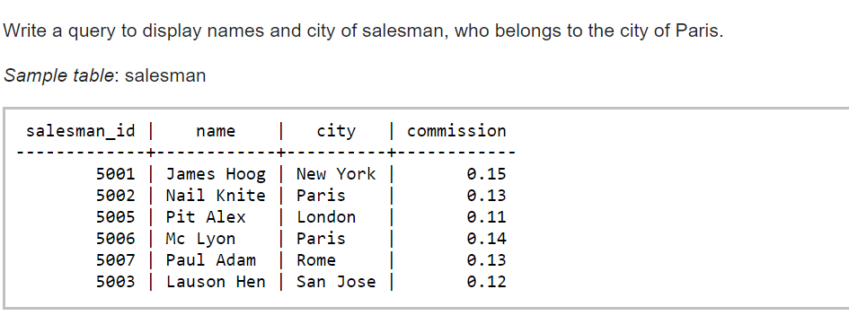

**Ans : select name,city from salesman where city=’Paris’;**

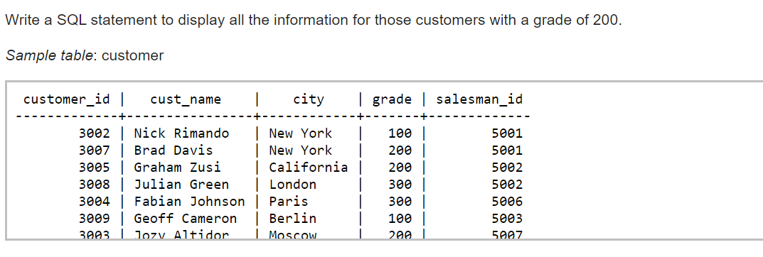

**Ans: select * from customer where grade = 200;**

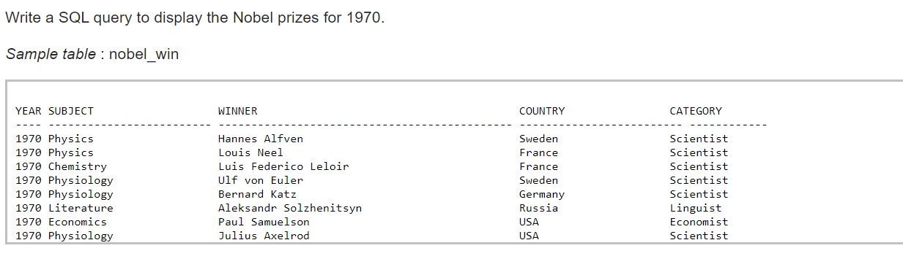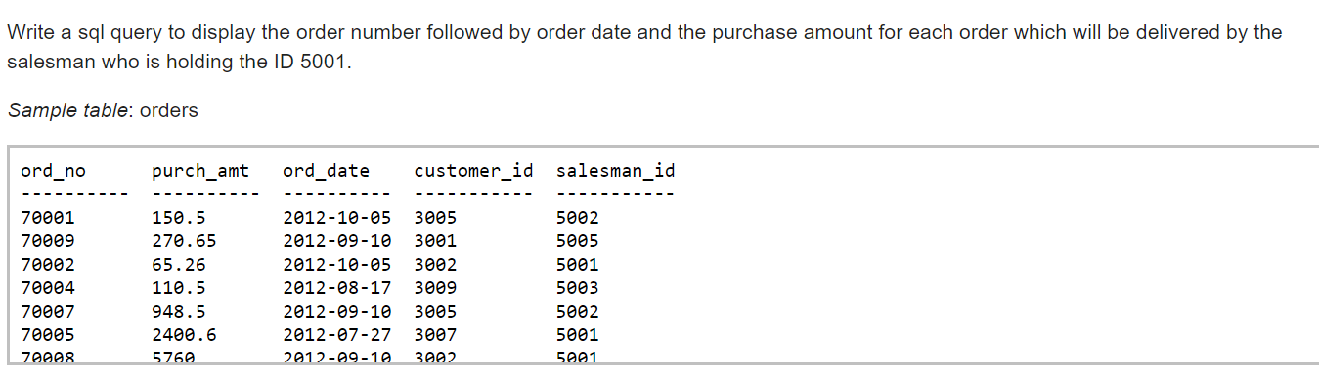

**Ans: select * from nobel_win where year=1970;**

**Ans: select ord_no,ord_date,purch_amt from orders where salesman_id =5001;**

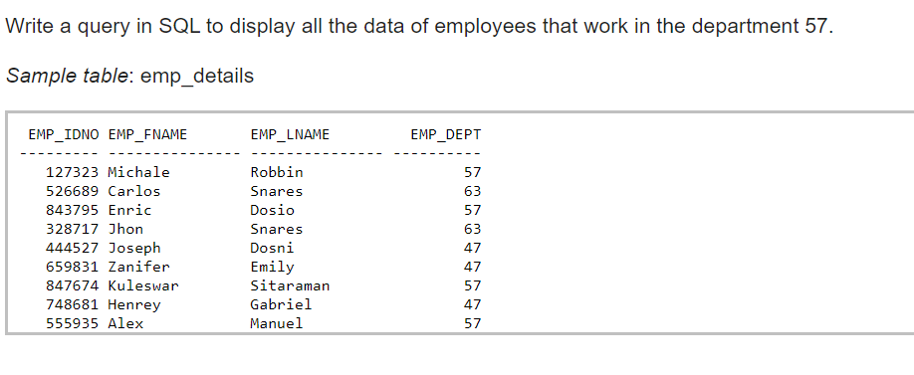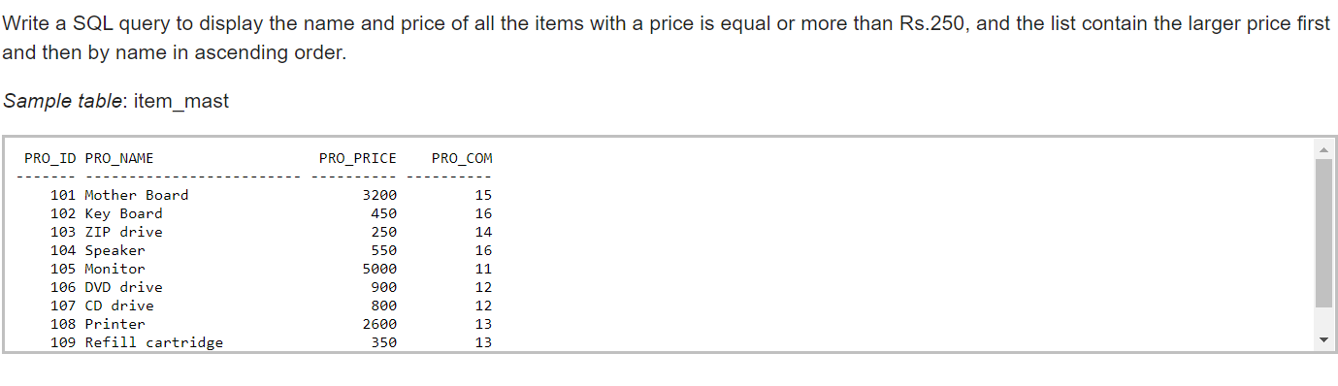

**Ans : select * from emp_info where emp_dept=57;**

**Ans : select pro_name,pro_price from item_mast where pro_price>=250 order by pro_price desc,pro_name asc;**

Ans: Select sum(Pro_pirce) from item_must;

select count(PRO_NAME) from item_mast;